TUM Open Infra Platform

Deployment Documentation

Content
About this Document 1
Getting started 1
Needed Software 1
Prerequisites 1
Using WiX Edit 2
Set-Up 2
Generating the installer 4
Releasing updates 5
Version number 5
Releasing 5

About this Document
This short guide shows you how to use the WiXEdit tool to generate an installer file for the project TUM Open Infra Platform.

Getting started

Needed Software
To be able to generate an installer you need to install the WiX Edit tool from http://wixedit.sourceforge.net/.

Prerequisites
To properly generate a *.msi installer you must first generate a deployment package. This is done as usual using the /deploy/deploy.py script. Call it using the build path (the same that you configured in CMake (“where to build the binaries”).
After having generated the *.zip deployment package, unpack it to a path of your choice. For this guide I will continue working inside of /deploy, but the path really does not matter.

Using WiX Edit
WiX-Edit is only used to generate the installer. For the tool to generate a *.msi file, we need to set-up a *.wxs file first.

Generating the WXS file
For this step it is necessary that you have unpacked the *.zip file from the previous step. Rename the unpacked folder to “TUM Open Infra Platform”. Then you can run the “generateInstaller.wxy.py” script to generate the “installer.wxs” file.

Generating the installer
Requires WiX binaries 3.0.5419.0 or later.
Now to actually generate the *.msi file, open WiXEdit and go to we just go to File > Open and select the “installer.wxs” file. Then Build > Build MSI setup package.
This will call “candle” and “light”. This step could be done using the command line manually, but it works just as fine from WiX Edit.
The console window at the bottom will show any errors that may occur.

If there were no errors, there will be an installer file (*.msi).
The temporary files (*.wixobj, *.wixpdb) can safely be deleted now.

Releasing updates

Version number
There are a few locations where the version number has to be updated.
- src\OpenInfraPlatform\version.h
Update Major.Minor.Build.Revision according to the new version.
- [ServerDirectory]/current_version.txt
This file must contain nothing BUT the newest version number. Our updater will compare the version from 1) with this text-file to decide whether to offer downloading a new version.
- deploy/installer.wxs
Update the “Version” attribute either via WiX-Edit or manually with a text-editor.
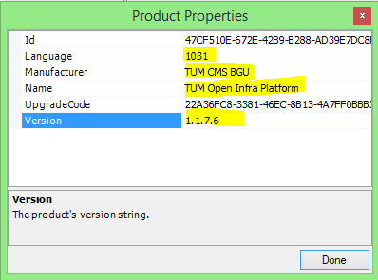

Releasing
To release a new version change the version number as explained above first. Generate a new *.msi file and place it on the server. Once the user starts the application, he will be asked whether he wants to download and install the new version (if one exists). Note that you can also manually check for updates using the menu (Help > Check for updates).
The installation process will remove any previous install and then install the new version.

